Nuclear Power:

An Alternative Energy Source?

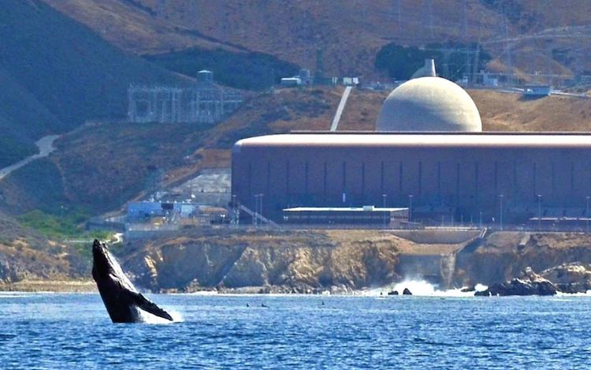

Figure . Diablo Canyon Nuclear Power Plant (John Lindsey)

You are going to write a one to two page evaluation of nuclear power as an alternative energy source, in the wake of disasters such as Fukushima and Chernobyl. You will do so in three separate steps:

# Step 1: Form Your Opinion

Watch the video clip, “Frontline Explores Nuclear Energy's Future,” (<https://youtu.be/LM7dLpAUNRo>) After the video, evaluate what you heard and saw, consider the alternatives, and do some preliminary research on the topic. Then, choose a position (for or against) as your claim. **Move on to Step 2.**

# Step 2: Organize Your Thoughts

With your claim (opinion) in mind, you will start to form your various facts, evidence and scientific reasoning into your favorite organizational format or outline. You may use any of the formats you have been taught, for example:

* Claim Evidence Reasoning (CER) from Science
* Main idea, Evidence, Analysis, and Link (MEAL) from English, or
* Document Based Question (DBQ) from LSN/Government.

**Have your teacher review this written document before moving to Step 3.**

# Step 3: Write Your Evaluation

Using the outline created in Step 2, write your formal evaluation (approximately 1-2 pages.) Ensure to (1) Evaluate the alternatives, (2) choose a position (for or against), (3) compare and contrast the position against the alternatives and (4) justify your choice with supporting facts and evidence and factual reasoning.

**Submit your final written document to your teacher.**